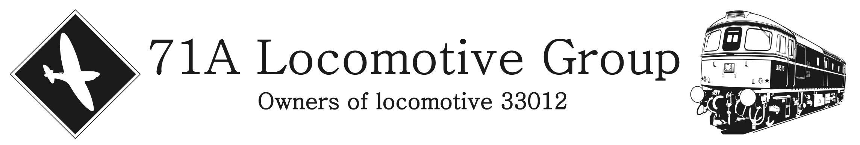

APPEAL FOR FUNDS FOR THE CAB OVERHAUL TO 33012

Amazingly it is now twelve full years since 33012 entered Eastleigh Works for her overhaul to mainline standard, and with any heritage vehicle (locomotive, bus, car, etc), time and the elements will still cause a certain degree of ageing and deterioration to components and bodywork, and 33012 is no different.
With this in mind at the 71A Locomotive Group 2020 AGM at Eastleigh Works in February 2020, it was agreed by the 71A Loco Group committee and membership that 33012 would enter Eastleigh Works during early autumn 2020, for a start to the corrosion overhaul of both of 33012’s cabs. During the overhaul to mainline standards that started in January 2009, only the lower couple of foot or so of both cabs was worked on, mainly related to repairs to the lower supporting cab structure, which had rusted where the supports are fixed to the mainframe. At the time the upper cab structure was serviceable. Twelve years later, now it is time to carry out repairs to the upper cab structure and the roofs of both of the cabs.
Unfortunately the COVID-19 pandemic delayed this overhaul during 2020, but on Monday 4th January 2021, 33012 travelled light engine from Swanage to Eastleigh Works on her own, and then that week the first of several 71A Locomotive Group working parties took place at the Works. This is allowed under the present COVID-19 restrictions, as this is covered under both the rules covering volunteering, and the rules regarding conducting work that can’t be down from home (well in fairness 33012 won’t fit in the garden !!!).
To help the 71A Locomotive Group raise some additional funds to allow this overhaul work to be carried out, the Group are looking for people to help by providing sponsorship for the items listed below and overleaf. If you are able to help out with this appeal for funds in any way possible, however large or small the donation, the 71A Locomotive Group would be most grateful.
Please Note – We were unsure whether to approach people for donations during these very tough times, particularly with so many people being furloughed or even made redundant, but we have been approached by several support group members and shareholders, asking if there was any monetary support they could provide towards this overhaul work. So with this in mind this appeal has been launched. Please only donate to this appeal if you can really afford to, and don’t make a donation if you can ill-afford too. Remember, this is only a hobby after all. Please look after your family and yourself first and foremost.
If you are able to make a donation, please fill out this form, particularly the last part with all your details (see overleaf), and return it to the address below (also see overleaf):-
Cost of the New Metalwork and Welding to 33012’s Upper Cab Structure
All the new metalwork and welding to 33012’s upper cab structure will cost the Group £5,000 in total. If you would like to help the Group out with the cost of these repairs, then please fill out this part of this form:-
5% of the costs (£250) 10% of the costs (£500) 25% of the costs (£1,250)

Cost of the Repairs to 33012’s Fibreglass Roof
All the repairs to 33012’s fibreglass roof and supporting woodwork will cost the Group £5,000 in total. If you would like to help the Group out with the cost of these repairs, then please fill out this part of this form:-
5% of the costs (£250) 10% of the costs (£500) 25% of the costs (£1,250)

Cost of the Fitment of Electric Windscreen Wipers to 33012
Due to the age of the present air driven windscreen wipers, and the difficulty in obtaining replacement parts, the Group has decided that while both cabs are completely stripped out, this would be a really good time to upgrade 33012 with electric windscreen wipers. This work will cost the Group £2,400 in total. If you would like to help the Group out with the cost of this upgrade, then please fill out this part of this form:-
5% of the cost (£120) 10% of the cost (£240) 25% of the cost (£600)

Continued Overleaf
Continued from Previous Page

Cost of the Full Repaint of 33012
The Group has been able to obtain a discount on the cost of the full repaint of 33012, and this discounted cost will come to a total of £12,000, as long as it retains its present green livery. If you would like to help the Group by sponsoring part of the repaint costs, then please fill out this part of this form:-
5% of the cost (£600) 10% of the cost (£1,200) 25% of the cost (£3,000)

Public Liability Insurance
The 71A Locomotive Group needs public liability insurance, to enable us to conduct our day to day business, such as using 33012 on the national railway network, and to cover our working members while they work on 33012 wherever she is in the UK. The Group has just paid the renewal for this insurance, and this presently costs the Group £2,820 this year. If you would like to help the Group by sponsoring some or all of the cost of the public liability insurance, then please fill out this part of this form:-
One Day (£7.75p) One week (£54.25p) One month (£235) One year (£2,820)

General Donations
If you would like to make a smaller donation to help towards any of the items mentioned above, or to cover the cost of other miscellaneous items, then please use this part of the form:-
£10 £20 £30 £40 £50 £100 Other £_____________

Your Details

Name:- ________________________________________________________________________________

Address:- ______________________________________________________________________________

______________________________________________________________________________________

______________________________________________ Postcode ______________________________

71A Locomotive Group Support Group / Share Holder Number:- ___________________________________

Are you a Class 71A Locomotive Group Support Member ? Yes No

If “No”, would you like to receive membership details ? Yes No

Are you a Class 71A Locomotive Group Share Holder ? Yes No

If “No”, would you like to receive information on purchasing shares ? Yes No

Please make cheques or postal orders payable to:- 71A Locomotive Group
Please return this form, along with any cheques or postal orders to:-
71A Locomotive Group, 5 The Delph, Lower Earley, Reading, Berkshire, RG6 3AN

Version 1.0 – 12th January 2021

